ABOUT

Banner image – “Walking shot”

**Intro**

**Heading - EXPERTS IN TECHNICAL COMMERCIAL TILES**

Content - With a strong reputation for excellence, Glennon Tiles proudly supply high quality tile products, sourced from around the world.

Having worked across many commercial sites, including several Australian icons, Glennon Tiles have the expertise and products to meet compliance standards for technical constructions, including for the aged care, education, hospitality, amenities and retail sectors.

Offering an extensive range of indoor and outdoor floor and wall tiles, our highly experienced team of in-house experts are on-hand to ensure the tile selection process is effortless – and perfectly tailored to your needs.

Glennon Tiles. Experts in technical commercial tiles.

Image – **Can we remove the image for this section as we don’t really have a photo suited for it and would just rather work without it 😊**

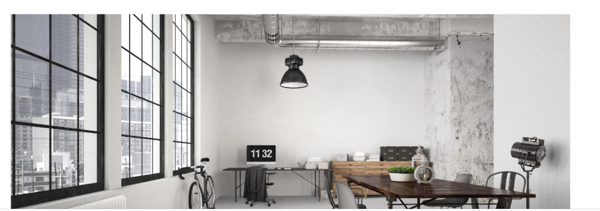

Section  1 - THE PAST

[Subhead]

**Heading - THE PAST**

Content - FS Glennon & Co was established in 1948, indenting ceramic tiles and other building materials. However, when import licensing changed in the late 1950s, the business started importing and merchandising ceramic wall and floor tiles – and Glennon Architectural Tiles was born.

Image – “The Past - Glennon Historical Shot”

Section  2 - THE PRESENT

**Heading - THE PAST**

Content - Glennon Tiles is at the forefront of technical tile development and commercial application. We’ve curated an exceptional collection and have also developed our own range of mosaic tiles. From humble beginnings, we now proudly partner with some of the most technically demanding industries around, including the education, aged care, government and retail sectors.

Image – as per email

Section  3 - THE FUTURE

**Heading - THE FUTURE**

Content - When you engage Glennon Tiles for your tiling project, you’ll experience an unparalleled quality of service and product. As Australian legislation changes and aesthetic demands evolve, our commitment to exceeding our clients’ expectations is further ingrained. We continue to be the reliable choice, and will be for generations to come.

Glennon Tiles are proudly positioned as industry leaders, able to confidently embark upon any tiling project, regardless of its complexity.

Image – “Futuristic building shot”